ECO-CLUB ACTIVITY & POINTS TRACKER
@CREATIVITY THINK (9483175986/7019689991)

ABSTRACT:
Eco-Club Activity & Points Tracker is a web-based system designed to monitor and encourage participation in environmental activities for school and college eco-clubs or community green groups. The platform allows members to join activities such as plantation drives, cleanups, and awareness campaigns, log their participation with evidence, and earn points and badges. Administrators can create activities, approve participation logs, verify evidence, and analyze overall impact through dashboards. Developed using Django and Django REST Framework for backend processing and React with recharts and axios for frontend interactions, the system promotes engagement, accountability, and measurable ecological impact..

INTRODUCTION OF THE PROJECT:
Environmental clubs often face challenges in tracking member participation, assigning points or rewards, and visualizing the overall impact of activities. Manual tracking methods are time-consuming and lack transparency. The Eco-Club Activity & Points Tracker addresses these challenges by providing a centralized platform where members can log activities, earn recognition, and visualize contributions, while administrators can manage events, verify logs, and monitor outcomes. This structured approach fosters engagement, encourages active participation, and promotes accountability..

PROJECT OBJECTIVES:

• Enable eco-club members to join and participate in activities
• Allow logging of participation with photos or evidence
• Award points and badges to encourage engagement
• Provide personal and team dashboards for impact visualization
• Allow administrators to create activities and point rules
• Approve participation logs and verify uploaded evidence
• Generate analytics on total activities, participants, and environmental impact
• Export reports for institutional or CSR purposes
• Promote structured and measurable environmental initiatives

PROBLEM OF THE STATEMENT:
Eco-clubs and community groups often struggle with unstructured tracking of activities, participation, and rewards. Paper-based or ad-hoc tracking methods fail to provide transparency, measurable impact, or effective reporting. Members may lose motivation due to lack of recognition, and administrators cannot accurately assess performance or environmental outcomes. This project addresses these issues by providing a digital solution that centralizes activity tracking, reward allocation, and impact reporting..

MOTIVATION OF THE PROJECT:
• To encourage participation in environmental activities
• To provide structured logging and verification of participation
• To reward members with points and badges for motivation
• To provide measurable impact dashboards for personal and team contributions
• To simplify administration of eco-club events and rules
• To allow exporting of reports for school or CSR evaluation
• To foster accountability, engagement, and environmental awareness
• To leverage digital tools for efficient tracking and analytics

BLOCK DAIGRAM OF PROJECT:

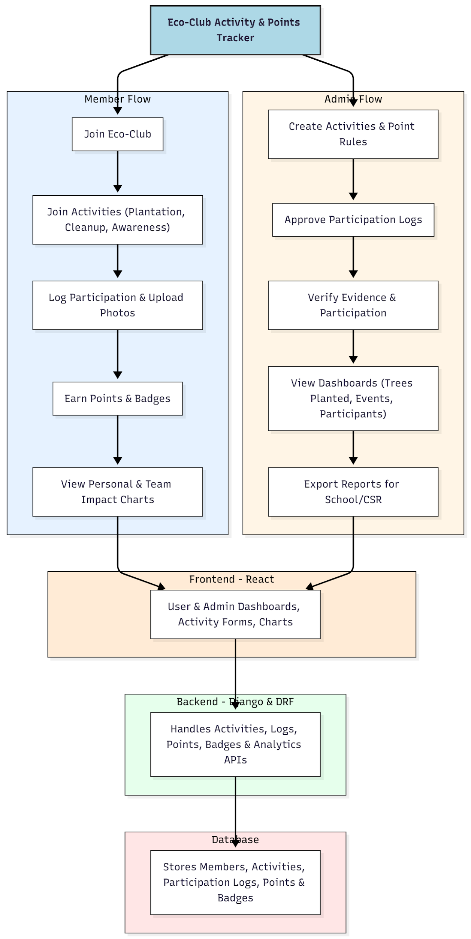

WORKING OF THE PROJECT:
Members join the eco-club and select activities such as plantation drives, cleanups, or awareness events. They log participation, upload evidence, and earn points and badges. Personal and team dashboards display contributions and impact metrics. Administrators create activities, define point rules, approve participation logs, verify evidence, and track overall club performance through dashboards. Monthly or periodic reports can be exported for institutional or CSR purposes. The backend manages all API requests, stores structured participation data, calculates points and badges, and provides analytics to the frontend dashboards, ensuring transparency, engagement, and measurable environmental impact..

SOFTWARE REQUIREMENT:
- Backend:
  - Python 3.x
  - Django
  - Django REST Framework
  - SQLite/PostgreSQL
- Frontend:
  - Node.js and npm
  - React.js
  - Axios
- Development Tools:
  - Visual Studio Code
  - Postman (for testing APIs)
  - Git/GitHub (for version control)
- Server/Deployment (Optional):
  - Gunicorn, Nginx, or Heroku/AWS for hosting

ADVANTAGES OF THE PROJECT:

• Encourages eco-club participation through points and badges
• Provides structured logging and verification of activities
• Offers dashboards for personal, team, and organizational impact
• Reduces administrative burden and manual tracking
• Improves transparency and accountability
• Supports report generation for schools or CSR initiatives
• Fosters engagement, motivation, and environmental awareness
• Enables data-driven decision making for activity planning

APPLICATIONS OF THE PROJECT:
• School and college eco-clubs
• Community green groups
• CSR initiatives in organizations
• Environmental NGOs tracking volunteer contributions
• Any structured eco-activity program

REFERENCES:

- Django REST Framework Documentation — Django Software Foundation. Django Documentation. Available: https://docs.djangoproject.com/
- Django REST Framework. DRF Documentation. Available: https://www.django-rest-framework.org/
- React. React Official Documentation. Available: https://reactjs.org/docs/getting-started.html
- Redux. Redux Documentation. Available: https://redux.js.org/introduction/getting-started
- PostgreSQL Global Development Group. PostgreSQL Documentation. Available: https://www.postgresql.org/docs/
- MySQL. MySQL Reference Manual. Available: https://dev.mysql.com/doc/
- Git. Git Documentation. Available: https://git-scm.com/doc
- Node.js. Node.js Documentation. Available: https://nodejs.org/en/docs/
- Axios. Axios Documentation. Available: https://axios-http.com/docs/intro
- Socket.io Documentation – https://socket.io/docs/

